QIN Tool survey summary

Revision history

Minor edits completed | Aug 11, 2014
Initial version prepared | Aug 6, 2014

Introduction
QIN Tools survey has been conducted in two iterations starting from the Spring 2014 [1]. In the beginning of Summer 2014, a revised version of the survey has been released [2]. The results of the survey are available at [3], and also include the analysis of other data sources (such as “QIN Matrix” [4], reports of the individual sites at the Face to Face meetings etc.). Individual tools could be used by multiple sites, and the survey was designed to facilitate collection of such multi-site usage information.

Summary analysis was done in several steps as presented in the following sections of this report. First, overall statistics summarizing site participation and tools usage has been extracted. Next, the list of tools has been reviewed to identify major platforms used by the QIN sites, in order to identify the common trends that might facilitate interoperability and sharing of the tools. Tools that were developed by the QIN sites or are not publicly available were analyzed separately. First, tools were grouped based on their functionality to identify potential intersections, which might create opportunities for cross-site validation studies in imaging biomarker development. Second, availability of the tools has been considered, to assess the potential for cross-site use and sharing of the tools, which are essential for QIN activities.

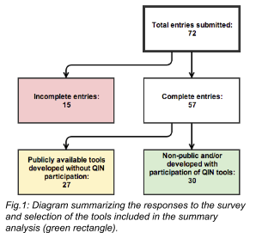
It is important to recognize that it is not expected that the survey lists all of the tools or reflects usage patterns of all sites. Rather, it provides a (possibly biased) sample of tool usage by the QIN community.

Overall summary
The survey included responses from 17 QIN sites: BWH, Columbia, Emory, Iowa, Mayo, MGH, Moffit/MAASTRO/USF, OHSU, UPMC, Stanford, UCSF, Vanderbilt, U. Washington, JHU, MSKC, U. Michigan (PI Ross) and MCW.

As shown in Fig.1, a total of 72 entries have been collected as the result of the survey as well as the analysis of the existing data. As of August 6, 15 of the entries were not complete, while 27 of the entries reported publicly available tools that were developed without participation of the individual sites (e.g., Matlab, IDL, Osirix, DCMTK). All entries, without exclusion, are available in the spreadsheet summarizing the results: http://goo.gl/05YGHU. Entries considered in this summary (those that were complete as of Aug 6) are marked in green in the spreadsheet.

Of the 72 tools reported by the QIN sites, 23 were used by more than one site. The tools that were used by at least 4 sites are the following:
- 8 sites: 3D Slicer and Matlab
- 7 sites: CTP
- 6 sites: OsiriX
- 5 sites: dcm4chee, IDL and NBIA
- 4 sites: PMOD, XNAT and GE Advantage Workstation
Note, that several of the commonly used tools can be used both as standalone tools, or as development platforms (3D Slicer, Matlab and OsiriX). Targeted investigation of the development platforms used by QIN was outside of scope of the current survey. Therefore, there is no information to comment on this aspect of tool usage.

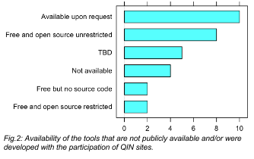
Analysis of tools developed with QIN participation
Categorization There were 30 complete entries for the tools developed with QIN participation. The following groups were identified based on the analysis of the primary purpose of the tool, based on the information provided about the tools:
- Pharmacokinetic analysis of dynamic MRI: 9 tools
- Radiomics: 3 tools
- Processing suite (defined as a collection of tools/processing steps that work together to achieve a specific task): 3 tools
- Data management: 3 tools
- Platforms (defined as software tools that are multi-purpose and possibly could be extended): 2 tools
- Segmentation: 2 tools
- PET quantification: 2 tool
- Registration: 1 tool
- Visualization: 1 tool
- Metrology: 1 tool
- DWI quantification: 1 tool

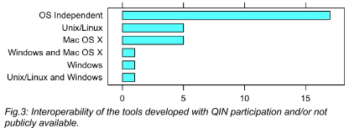
2 tools were not included in the analysis above, since their purpose was not clear from the description provided by the sites (“image processing” and “General use package for (mostly) MRI image analysis”, respectively), and the tools were not publicly available to learn more details.

Availability Availability of the tools is summarized in Fig.2. Note that in the process of data normalization, two new categories for availability were added: “Available upon request” and “To be determined (TBD)”.

FDA clearance 6 of the tools developed with QIN participation were reported as approved by FDA for clinical use (specifically, IB suite of tools reported by MCW, and brtool reported by UCSF).

Interoperability Most of the tools appear to be OS-independent, with the detailed interoperability distribution summarized in Fig.3.

Conclusions
Detailed results of the survey (the spreadsheet referenced) as well as the presented high-level summary are available to the QIN community as a resource to raise awareness of the on-going tool usage and development, facilitate collaborative projects and cross-validation of the tools.

References
[1] QIN Tools survey version 1: http://goo.gl/3oyIM7
[2] QIN Tools survey version 2: http://goo.gl/aJapvE
[3] QIN Tools inventory spreadsheet: http://goo.gl/05YGHU
[4] QIN Matrix: http://goo.gl/P39MQz

