Here are some instructions for the eeDAP mitotic counting study at Memorial Sloan Kettering Cancer Center beginning June 2017. Sections labeled MicroRT mode (microscope real time mode) do not need to be performed when the study is run in digital mode. There is a user manual at <http://didsr.github.io/eeDAP/000_EEDAP/manualHTMLDraft/> and there are videos demonstrating how to run eeDAP in digital and microRT modes (open input file, register the slide/image in microRT mode, collect data). The videos are at <https://www.youtube.com/channel/UC60GQmixBDjQ1Cuidj7n5pQ> .

**Both evaluation modes**

Turn on the monitor. Turn on the computer and log in as "bdg". No password is required.

**MicroRT mode**

Install the slides on the microscope with labels away from the user. The slide positions are numbered from right-to-left (1. CCB050031HE; 2. CCB010352HE; 3. CCB030097HE; 4. CCB030179HE)

|  |  |  |  |
| --- | --- | --- | --- |
| CCB030179HE | CCB030097HE | CCB010352HE | CCB050031HE |
|  |  |  |  |

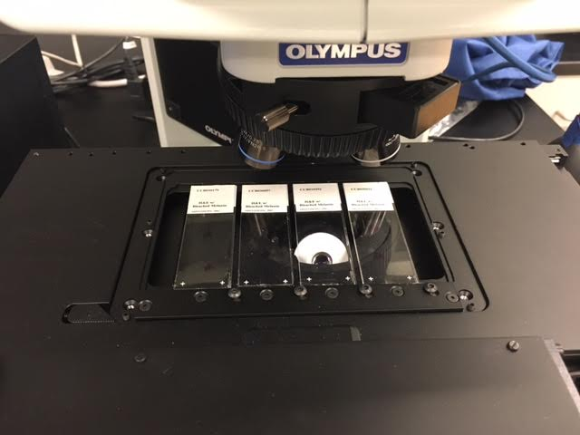

Turn on the microscope; the switch is on the left side, front-facing, and midway up the microscope vertically

Turn on the stage controller; the switch is in the back on the bottom-right.

**Both evaluation modes**

**Run eeDAP with the App**

Launch eeDAP by double-clicking the App icon on the desktop.

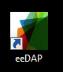

**Run eeDAP within MatLab**

If you are having trouble running the eeDAP app, we may want to run it in within MatLab instead. This will allow for trouble shooting and will show errors encountered. This information is not available when running the app. If you are not encountering problems running the eeDAP app, you can skip this section.

Launch eeDAP within MatLab by first launching MatLab; double-click on the MatLab icon on the desktop.

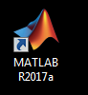

MatLab should open as it appears below, the editor tab selected and the "Administrator_Input_Screen.m" showing in the editor. Click in the editor and then click on the run button. If the run button is not showing, it is because you haven't clicked inside the editor.

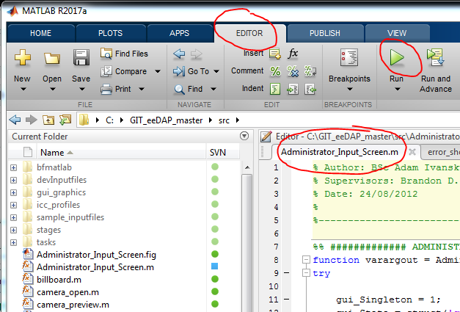

The Administrator_Input_screen GUI will open. At the top, "Click to browse for .dapsi input file". Browse to one of the following files depending on the session work assignment:

* C:\Users\bdg\Documents\eeDAPstudyMSKCC\mitotisCounting\MC_HE1.dapsi
* C:\Users\bdg\Documents\eeDAPstudyMSKCC\mitotisCounting\MC_HE2.dapsi

Click "Extract ROIs". Click "Select Viewing Mode". Click "Start the Test".

**MicroRT mode**

This step in the eeDAP MircoRT mode is the registration of the stage coordinate system to the WSI pixel coordinate system. The notes below are brief but not complete. Please refer to the manual Section VI. "WorkFlow MicroRT Registration," or refer to the demo videos at <https://www.youtube.com/channel/UC60GQmixBDjQ1Cuidj7n5pQ>

If it hasn't been done before, you must do low-resolution registration for each image/slide. This study expects low-resolution registration to be done with 10x magnification (the mag_lres parameter in the input file is set to 10). Set the microscope to use the 10x objective and perform low-resolution registration. When complete click "Load last calibration" and continue with high-resolution registration.

NOTE: Do not select registration locations too close to the image boundary. You can get an error if the registration tries to access pixels that are outside the image. Make sure the outer green square indicating the camera view lies completely within the image.

Note: Low-resolution requires 3 anchors/locations. These locations should be sparated as far apart as reasonably possible. These locations should contain easily identifiable structure.

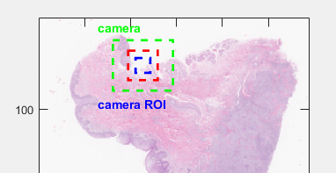

If low-resolution registration has been done before, you can click on "Load last calibration" and skip to high-resolution registration.

This study expects high-resolution registration to be done at 40x. Set the microscope to use the 40x objective and perform high-resolution registration.

After clicking on "GoTo position 1 (2 or 3)", do not move the microscope stage too quickly. First look at the camera image and try and correlate tissue to that within the WSI image. The camera image should show tissue that is in the WSI. If you navigate away from this, it might be hard or even impossible to register the two.

The final step in regstration is possibly the most important: the registration of the eyepiece and the camera. Please take your time on this important step.

**Both evaluation modes**

The **definition of a mitosis** for this study is the following

*Criteria for a mitosis includes the loss of a nuclear membrane with condensation of chromatin forming the mitotic apparatus. The formation of the nuclear membrane within two daughter cells, signifies the end of the mitotic process and should not be counted as a mitosis.*

The evaluation area for this study is bounded by the fourth smallest square (Number 8 shaded area) in the reticle. See the picture.

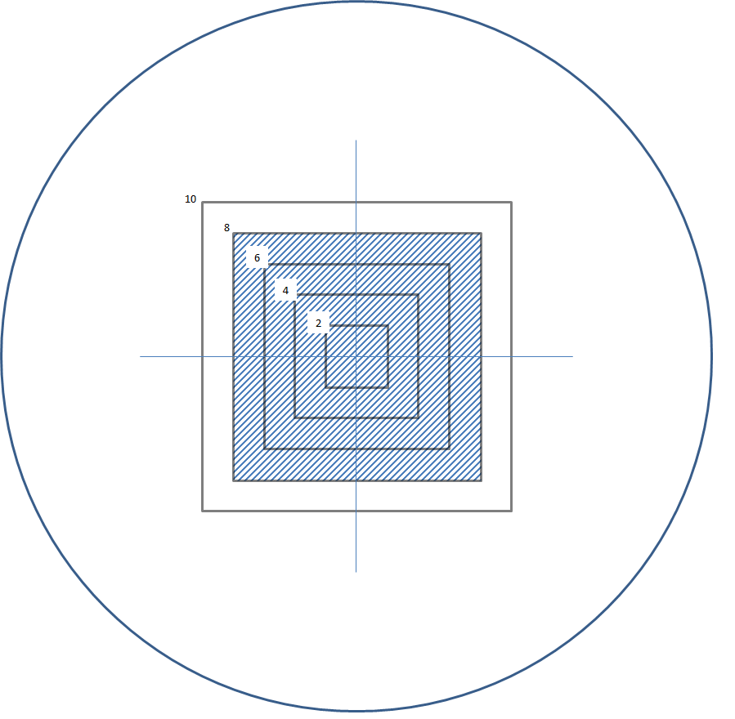

**Shut down all equipment**

Microscope. Stage controller. Monitor. Computer.