Overview
This data collection procedure describes a method for collecting the following information from multiple pathologists using digitized histological sections of breast cancer: 1) mitotic (Nottingham) scores from preselected image regions and 2) confidences measures indicating a pathologist’s certainty that an individual nucleus is a mitotic figure.

Mitosis collection protocol
- Our in-house pathologist selects 100 mitosis regions from 100 different patients (i.e. one region per patient) exhibiting the following characteristics:
  - Each area is a rectangle with an area equivalent to 10 fields-of-views (FOV) at 40x magnification
  - The distribution of mitotic scores across patients is approximately
    - 33% with scores of 3
    - 33% with scores of 2
    - 33% with scores of 1
- From each rectangle, our in-house pathologist selects a representative box (2000x2000 pixels at approximately 0.25 microns per pixel)
- Within each box, our in-house pathologist places a dot on each nucleus that could conceivably be a mitosis

Mitosis scoring protocol
Each (10 FOV) rectangle is sent to seven breast cancer pathologists who examine the entire rectangle and record the mitotic score.

Individual Mitosis Evaluation
Each (2000x2000) box is sent to the seven breast cancer pathologists. Within the box, each mitosis is examined (facilitated by our web-based viewer, which magnifies each mitosis in succession) and categorized as follows:

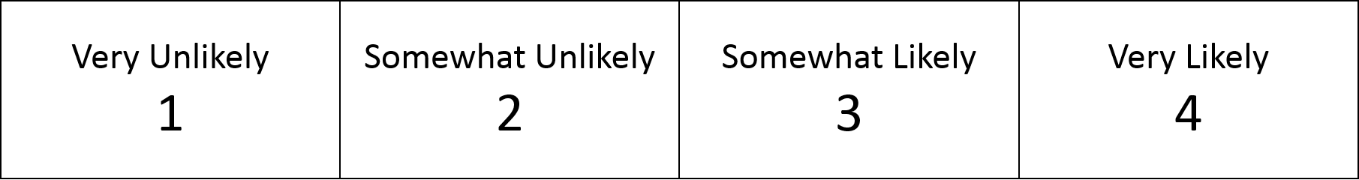

This is the largest number of cases I think we can get pathologists to do in a reasonable time.
Several different data sources should become available. The data used will depend upon which arrives first.
This is the area recommended by CAP guidelines for measuring mitotic score.
Using our in-house pathologists is slow. Our engineers could probably do this quickly, and should do well enough.
We still need to recruit them. We have done something similar before, and it should not be a problem. In case of difficulties, we could relax the requirement of being a breast pathologist.
We could increase the number of samples (from the proposed 100) by sending only a subset of the cases to each pathologist. However, this adds another source of variability and could impact the statistical value of each sample.
Our viewer was designed to facilitate such experiments. Without it, such experiments would require too long.

